Formal Languages

* an alphabet is a non-empty, finite set of symbols, often denoted by Σ (capital sigma)
  + like a lexicon/dictionary
  + e.g. Σ = {WHILE, IF, ELSE, VAR, NUM, EQUALS, BECOMES, PLUS, ...} alphabet of elements in a programming language
  + e.g. Σ = {0, 1} alphabet of binary digits
* a string/word w is a finite sequence of symbols chosen from Σ
  + set of all words over an alphabet Σ is denoted by Σ\*
  + length of word is denoted by |w|
* ε (epsilon) is the empty string
  + assume Σ will never contain ε since it’s just a notational convention for the empty string
* language is set of strings
  + e.g. L = ∅ or {}, the empty language
    - size = 0
  + e.g. L = {} the language consisting of the empty string
    - size = 1
  + e.g. L = {abna : n ∈ N} the set of strings over the alphabet Σ = {a, b} consisting of an a followed by 0 or more b characters followed by an a
* a language may be finite or infinite
* a language L over alphabet Σ is by definition a subset of Σ\*
  + Σ\* is also a language itself
* a recognition algorithm is a decision algorithm that takes the specification of a language and an input word, then answers whether the word satisfies the specification (i.e. whether the word is in the language)
  + a compiler does recognition, but then also translates the program into a different output language
* in order of relative difficulty on how hard it is to recognize languages: finite, regular, context-free, context-sensitive, recursive/decidable, and undecidable

Finite Languages

* since a finite language is a finite set of words, one way to specify the language is to list all the words but more efficient ways exist
* example of efficient recognition algorithm for finite language below:

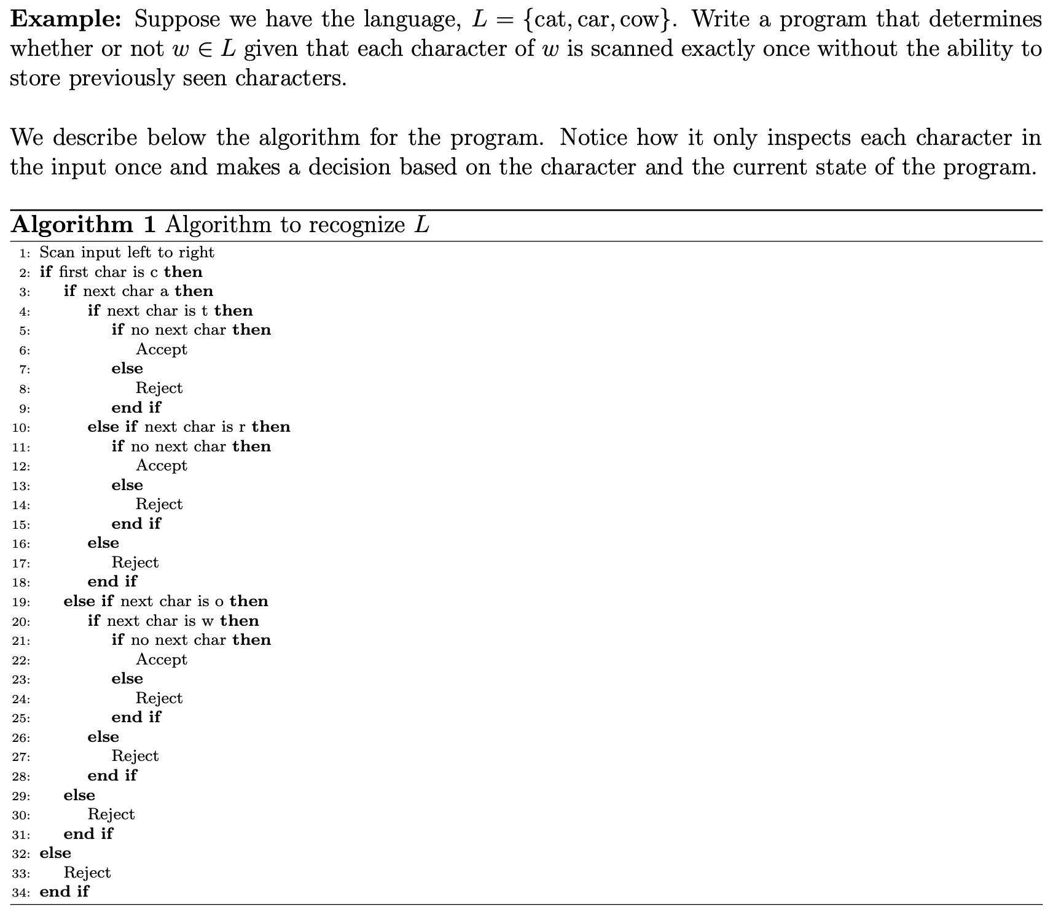

* + this can be represented more concisely as a state diagram

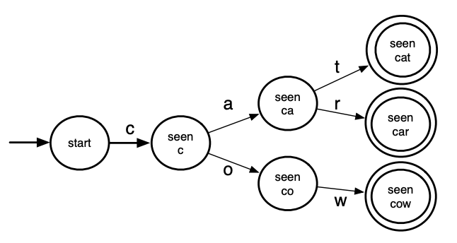

* + - each bubble rep a state: configuration of program based on input seen/scanned so far
    - there’s unique start state, denoted by arrow into it
    - arrows from state to state are labelled and rep transitions based on the next input symbol
    - if transition isn’t defined for the next input symbol, state transitions to implicit error state
    - accepting states have 2 circles

Regular Languages

* language over an alphabet Σ is a regular language if
  + it’s the empty language, {}, or the language consisting of the empty word, {ε}
  + it’s a language of the form {a} for some a ∈ Σ
  + it’s a language built using the union, concatenation or Kleene star of 2 regular languages
* let L1, L2, and L3 be regular languages; the following are also regular languages:
  + union: L1 ∪ L2 = {x : x ∈ L1 or x ∈ L2}
  + concatenation: L1L2 = {xy : x ∈ L1, y ∈ L2}
* Kleene star: L\* =

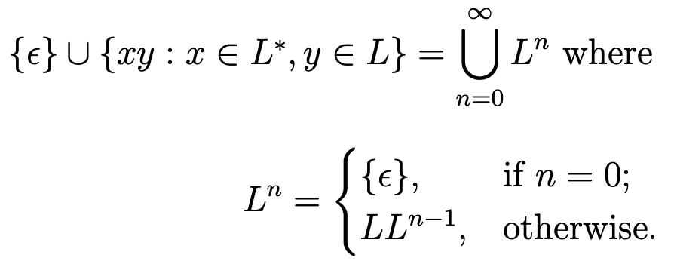

* + L\* is set of all strings consisting of 0 or more occurrences of strings from L concatenated together
* e.g. suppose L1 = {up, down}, L2 = {hill, load}, and L = {a, b} over appropriate alphabets:
  + L1 ∪ L2 = {up, down, hill, load}
  + L1L2 = {uphill, downhill, downhill, download}
  + L\* = {ε, a, b, aa, ab, ba, bb, aaa, aab, aba, abb, baa, bab, bba, bbb, ...}
* regular expressions are a way of expressing regular languages
* with notations, we drop set notation:
  + {ε} becomes ε
  + L1 ∪ L2 becomes L1 | L2
  + concatenation is still • or implicit
  + empty language is still ∅
* order of operations is \*, •, then |
* e.g. L = {abna : n ∈ N} is written as ab\*a as regular expression
* can use state diagrams to pictorially rep regular languages
  + since regular languages can be infinite, self-loops are introduced into state diagrams
* state diagrams are called deterministic finite automata (DFA)
  + transitions are deterministic, meaning for each state, there’s only one transition on a given symbol (i.e. can’t define multiple transitions from one state on the same symbol)

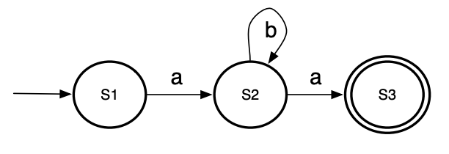

* a DFA is a 5-tuple (Σ, Q, q0, A, δ):
  + Σ is a finite non-empty set (alphabet)
  + Q is a finite non-empty set of states
  + q0 ∈ Q is a start state
  + A ⊆ Q is a set of accepting states.
  + δ : (Q × Σ) → Q is our [total] transition function (i.e. given a state and a symbol of our alphabet, which state to go to)
* e.g. DFA for L = ab\*a, Σ = {a,b}, Q = {S1,S2,S3}, q0 = S1, A = {S3}, and δ(S1, a) = S2, δ(S2, b) = S2 and δ(S2, a) = S3
* another example of a DFA:

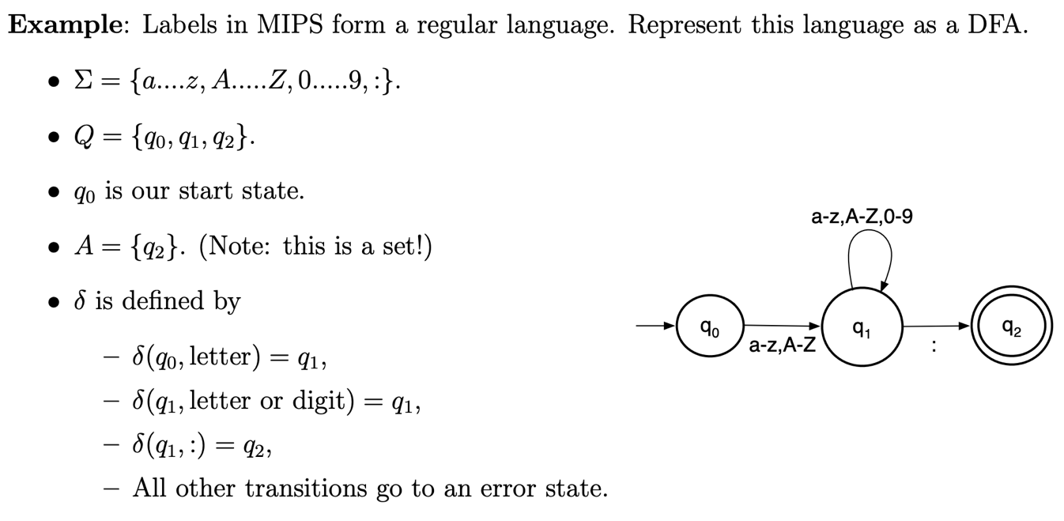

* to define a recognition algorithm for a word w in a regular language using a DFA, first extend definition δ : (Q × Σ) → Q recursively to a function δ\* : (Q × Σ\* ) → Q by doing:

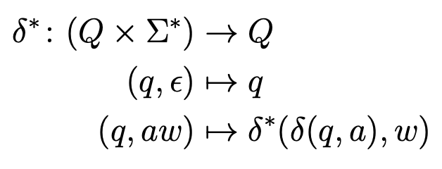

* + a ∈ Σ and w ∈ Σ\*
  + δ\* processes a string by processing the first character, then processing the rest of the string recursively
* DFA given by M = (Σ, Q, q0, A, δ) accepts a string w if and only if δ\*(q0, w) ∈ A
  + to recognize a word w=a1a2a3...an, start at DFA’s start state q0 and transition on first symbol a1 to end up at some qi
  + then, transition on a2 from qi
  + repeat until we have transitioned through all symbols a1...an
  + if resulting state is accepting, we accept and reject otherwise
  + with implicit error states, if transition is undefined, reject right away
  + as an algorithm:

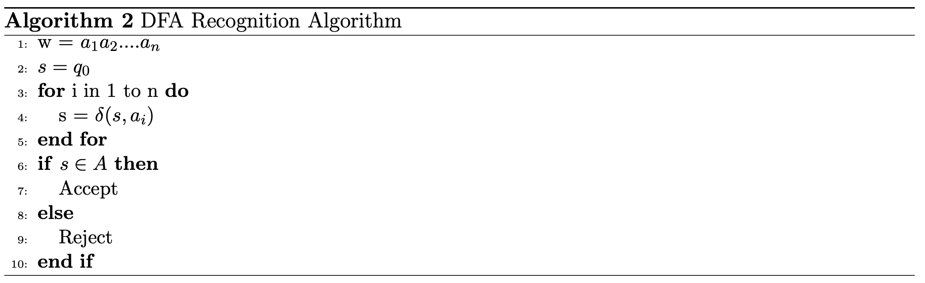

* e.g. using the above DFA for MIPS labels, we can run the recognition algorithm:

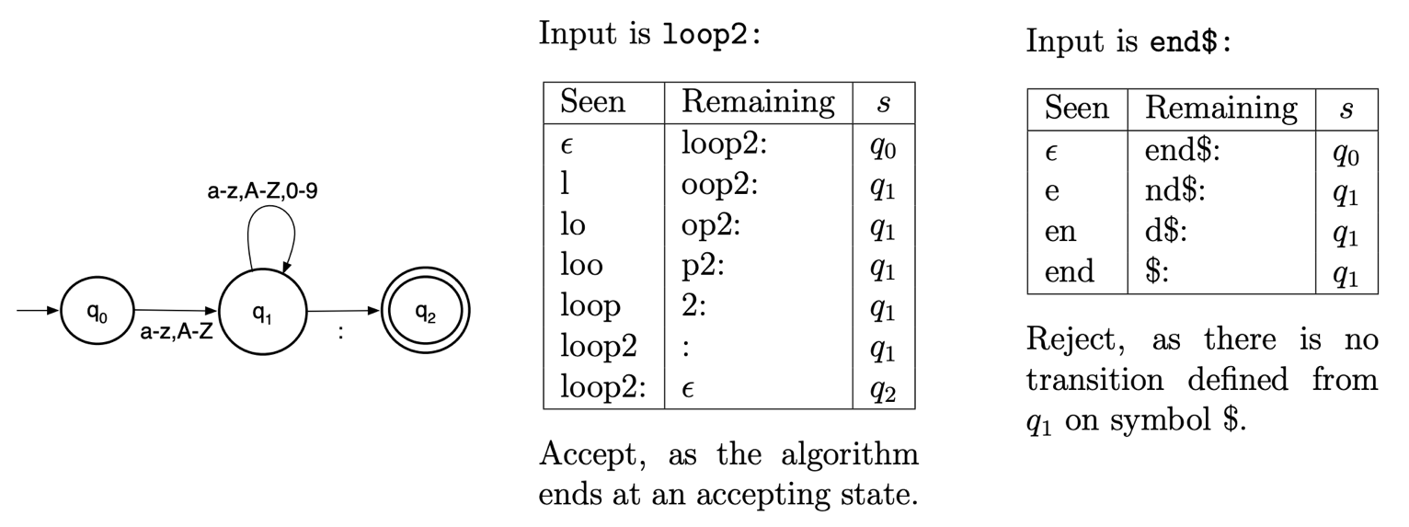

* the language of a DFA M, denoted L(M), is set of all strings accepted by M: L(M) = {w : M accepts w}
* theorem 1 (Kleene): L is regular iff L = L(M) for some DFA M
  + i.e. regular languages are precisely the languages accepted by DFAs
* can extend DFAs by attaching actions to each transition
  + aka finite transducers
  + e.g. a DFA that simultaneously detects if word is a subset of the language of binary numbers without leading zeroes and prints out the decimal rep

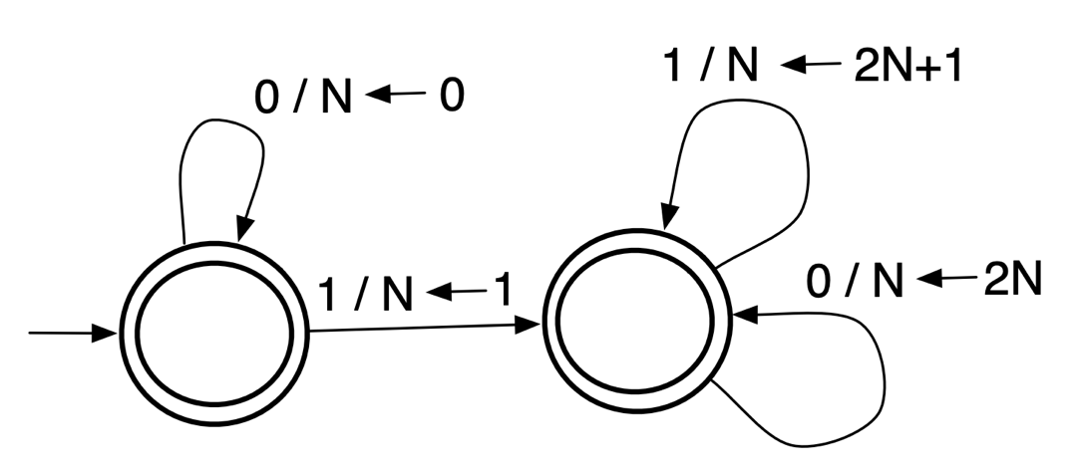

* + - read 1/N ← 2N + 1 as the left 1 corresponding to a DFA transition and the N ← 2N + 1 changes N to be 2N + 1
* DFAs are used in Scanning stage of compiler, where input is sequence of characters rep program and output is sequence of tokens
* non-determinism is when the machine can choose which path to go on
* e.g. consider DFA for L = {w : w ends with bba} over the alphabet Σ = {a, b}

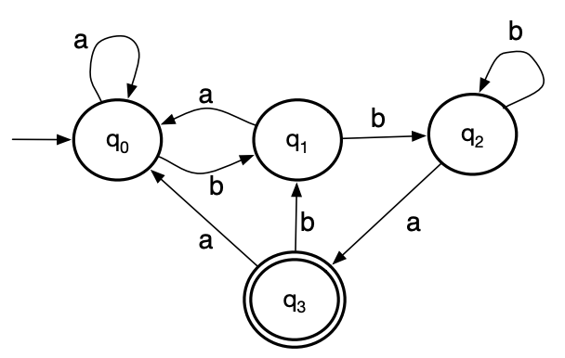

* a non-deterministic finite automata (NFA) can be used to simplify the DFA
  + e.g. for above DFA, an NFA chooses to stay at q0 until the ending bba

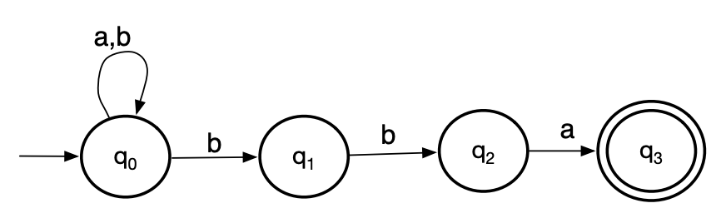

* + an NFA allows for more than one transition from a state on the same symbol
* NFA is a 5-tuple (Σ, Q, q0, A, δ):
  + Σ is a finite non-empty set (alphabet)
  + Q is a finite non-empty set of states
  + q0 ∈ Q is a start state
  + A ⊆ Q is a set of accepting states
  + δ : (Q × Σ) → 2Q is our [total] transition function. Note that 2Q denotes the power set of Q, that is, the set of all subsets of Q
* only difference between DFA and NFA is how transition function is defined
  + in NFA, a state and symbol combination can lead to a set of states instead of a single new state
  + all DFAs are NFAs
* to get recognition algorithm, extend the definition of δ: (Q × Σ) → 2Q to a function δ\* : (2Q × Σ\* ) → 2Q by doing:

* + a ∈ Σ
  + δ\* processes a string by processing the first character, then processing the rest of the string recursively
  + since the input to δ is a single state and our result is a set of states, we must make a union of all the states as separate inputs
    - as long as one end state is accepting, the input is valid
* an NFA given by M = (Σ, Q, q0, A, δ) accepts a string w if and only if δ\* ({q0}, w) ∩ A != ∅
  + to recognize a word w=a1a2…an, start at NFA’s start state q0 and transition on first symbol a1 to end up in set of states Si
  + then, transition on each state qi from Si on symbol a2 to new set of states
  + repeat until we have transitioned on all of the symbols
  + if the resulting set of states contains an accepting state, we accept and reject otherwise

* e.g. using above NFA for recognizing if a word ends on bba, we can run recognition algorithm on input word abbba:

* the language of an NFA M to be the set of all strings accepted by M: L(M) = {w: M accepts w}
* NFAs are not more powerful than DFAs because even the power-set of a set of states is finite
  + rep set of states in NFA as single states in DFA
* to run regular languages, convert it to NFA and then convert it to DFA
* to convert from NFA to DFA:
  + start with state S = {q0}
  + from this state, go to each NFA and determine what happens on each symbol a ∈ Σ for each state q ∈ S
    - set of resulting states should become its own state in DFA
  + repeat for each new state until we have exhausted every possibility/combination of states
  + accepting states are any states that included an accepting state in the original NFA
* example of converting NFA to DFA:

* ε-Non-Deterministic Finite Automata permits state transitions without consuming a symbol
  + ε-transitions make it easy to construct concatenation of two NFAs and Kleene star of NFA
  + e.g. for the language L = {abc} ∪ {w: w ends with cc}, create an ε-NFA by creating a new start state and connecting it to the NFAs for {abc} and {w: w ends with cc} using ε transitions

* an ε-NFA is a 5-tuple (Σ, Q, q0, A, δ):
  + Σ is a finite non-empty set (alphabet) that does not contain the symbol ε
  + Q is a finite non-empty set of states
  + q0 ∈ Q is a start state
  + A ⊆ Q is a set of accepting states
  + δ: (Q × Σ ∪ { ε }) → 2Q is our [total] transition function
    - 2Q denotes the power set of Q (i.e. the set of all subsets of Q)
* epsilon closure E(S) is set of all states reachable from S in 0 or more ε-transitions
* to get recognition algorithm, extend the definition of δ: (Q × Σ ∪ { ε }) → 2Q to a function δ\* : (2Q × Σ\* ) → 2Q by doing:

* + a ∈ Σ
* an ε-NFA given by M = (Σ, Q, q0, A, δ) accepts a string w if and only if δ\* (E{q0}, w) ∩ A != ∅
  + recognition algorithm is same as NFA except that for each set of states, including the start state, we compute its epsilon closure

* e.g. trace 2 below inputs on previous ε-NFA for L = {abc} ∪ {w: w ends with cc}

* an ε-NFA exists for every regular language

Scanning

* Scanning stage is conversion of sequence of characters into tokens
* in C, keywords, identifiers, literals, operators, and comments are regular expressions
  + finite automata can do the scanning/tokenization
* maximal munch scanning algorithm is greedy algorithm
  + i.e. it attempts to consume the max number of characters it can
  + e.g. consider input string s = ababca with Σ = {a, b, c}, L = {a, b, abca} and the DFA as shown below:

* + - first consumes ‘a’ and flags q1 as a state because it’s accepting
    - then, consumes ‘b’ and moves on to state q2
    - algorithm is stuck because it’s not at an accepting state and there’s no transition on the symbol ‘a’
    - so, it backtracks to last accepting state and un-consumes the previous input since that last state
    - since last seen accepting state is q1 where only ‘a’ has been consumed, algorithm outputs that token and resets to the start state q0
    - resumes consuming ‘b’ and q5 as last seen accepting state
    - algorithm becomes stuck and since current state is accepting, ‘b’ is outputted and resets to q0
    - keeps going until the entire string has been consumed
* simplified maximal munch algorithm is same as maximal munch, but it doesn’t include the backtracking
* difference between the 2:
  + maximal munch: consume characters until there’s no valid transition; if there’s still characters left to consume, backtrack to the last valid accepting state and resume
  + simplified maximal munch: consume characters until there’s no valid transition; if current state is accepting, produce the token and proceed; otherwise go to an error state
* e.g. for input string s = ababca with Σ = {a, b, c}, L = {a, b, abca} and DFA as shown above, simplified algorithm would reject the token
  + can use whitespace to account for these limitations and have the input string be w = a b abca

* algorithm for simplified maximal munch (assuming input machine is DFA (Σ, Q, q0, A, δ)

* + assumes function peek(w) returns next symbol without consuming it and consume(w) consumes and returns next symbol from input (while mutating input string)